**Methodology**

**Input2 Pushbutton**

This portion was for taking input from the user and pass it to the particular operation. Apart from autocorrelation and autocovariance, every other operation needed two inputs. For this purpose, one pushbutton was introduced –

*Input2* : For the first input, numbers were selected normally. Those numbers were visible in the “Entry” static text box. Once input 1 was done, then this “Input2” pushbutton was pressed. After pressing this pushbutton, the numbers/vector from he “Entry” static text box were set to the “Input1” static text box and “Entry” box get cleared. Then normally again numbers were given for input 2. It should be visible in “Entry” box. And if then any operation was chosen, the vector from “Entry” box was set to “Input2” static text box and like before, “Entry” box get cleared. Using ‘setappadata’ and ‘getappdata’ functions, input 2 value was transferred among all the operations.

For autocorrelation and autocovariance, only one input was needed. So here the “Input2” pushbutton was not necessary.

**Clear Pushbutton**

This pushbutton performed the operation of clearing all the axes in the GUI platform, Input1 box, Input2 box and Output box.

**Delete Pushbutton**

In the ‘Entry’ static text box, the last most string can be omitted by this pushbutton.

**Result and Discussion**

As previously mentioned, a GUI platform was used to represent the project. For every operation, the result we got from GUI platform, matched with the result from running in the main MATLAB file. Following is a presentation of that statement –

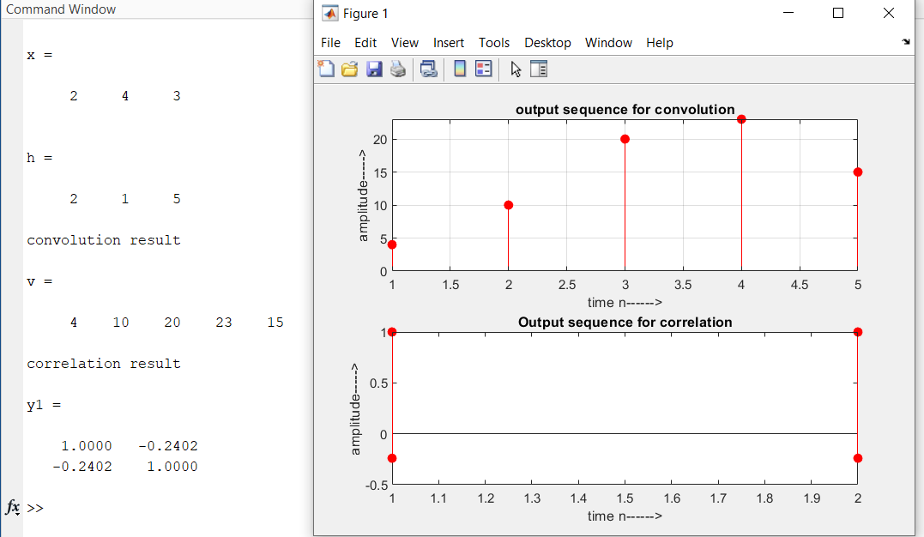

(a)

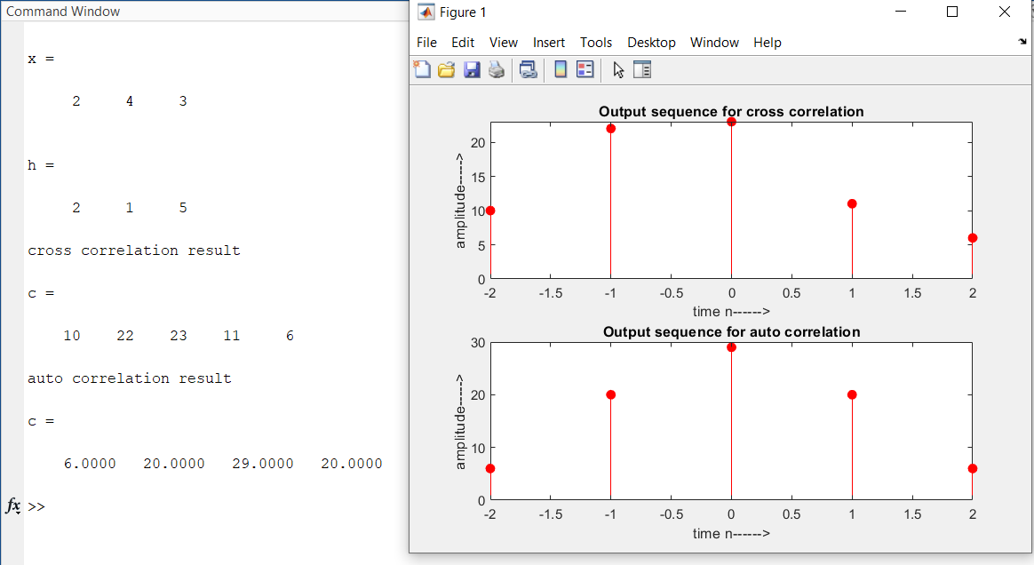

(b)

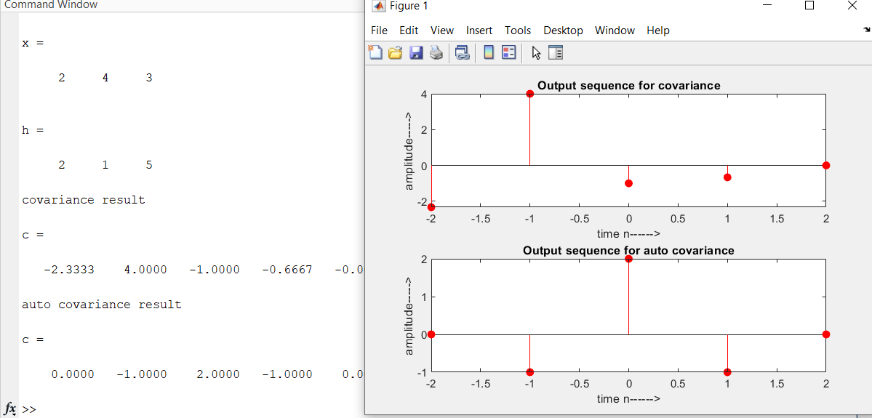

(c)

**Fig.1** – Results for different operation in MATLAB command window (a) convolution and correlation operation (b) cross correlation and auto-correlation operation (c) covariance and auto-covariance operation

If **fig.1** and **fig.2** is compared, it can be showed that every operation’s result which was done in MATLAB command window, matches with the result that we got from GUI platform. This proves the accuracy of the project.

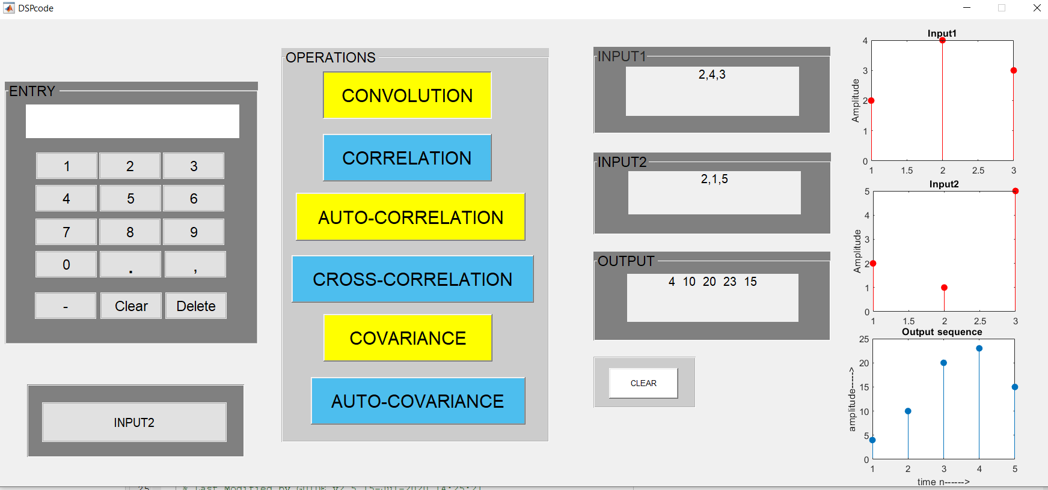

(a)

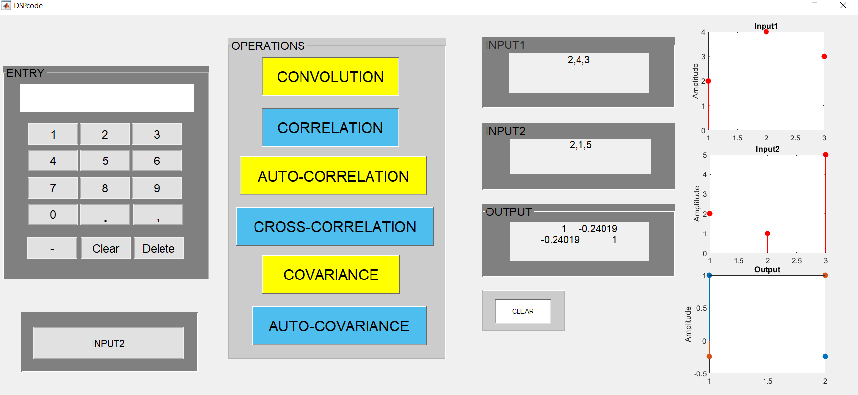

(b)

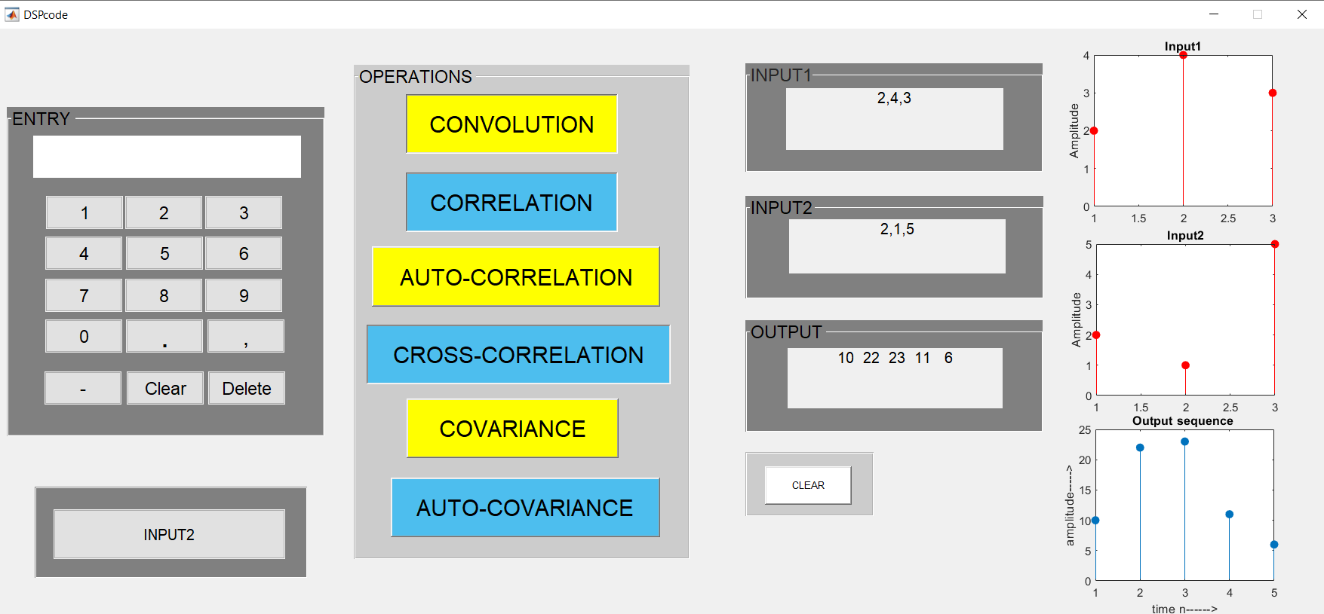

(c)

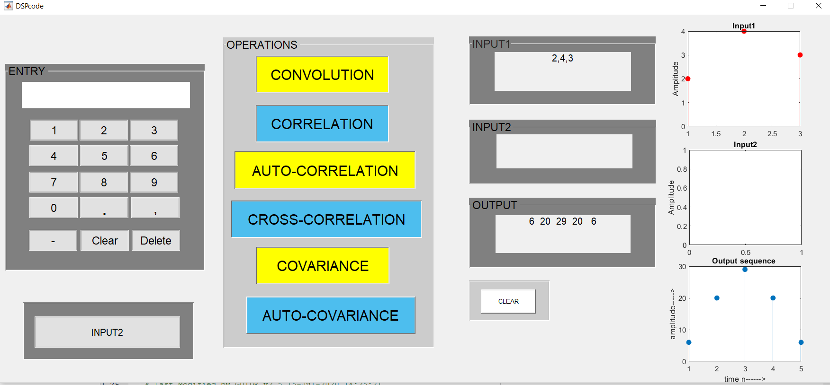

(d)

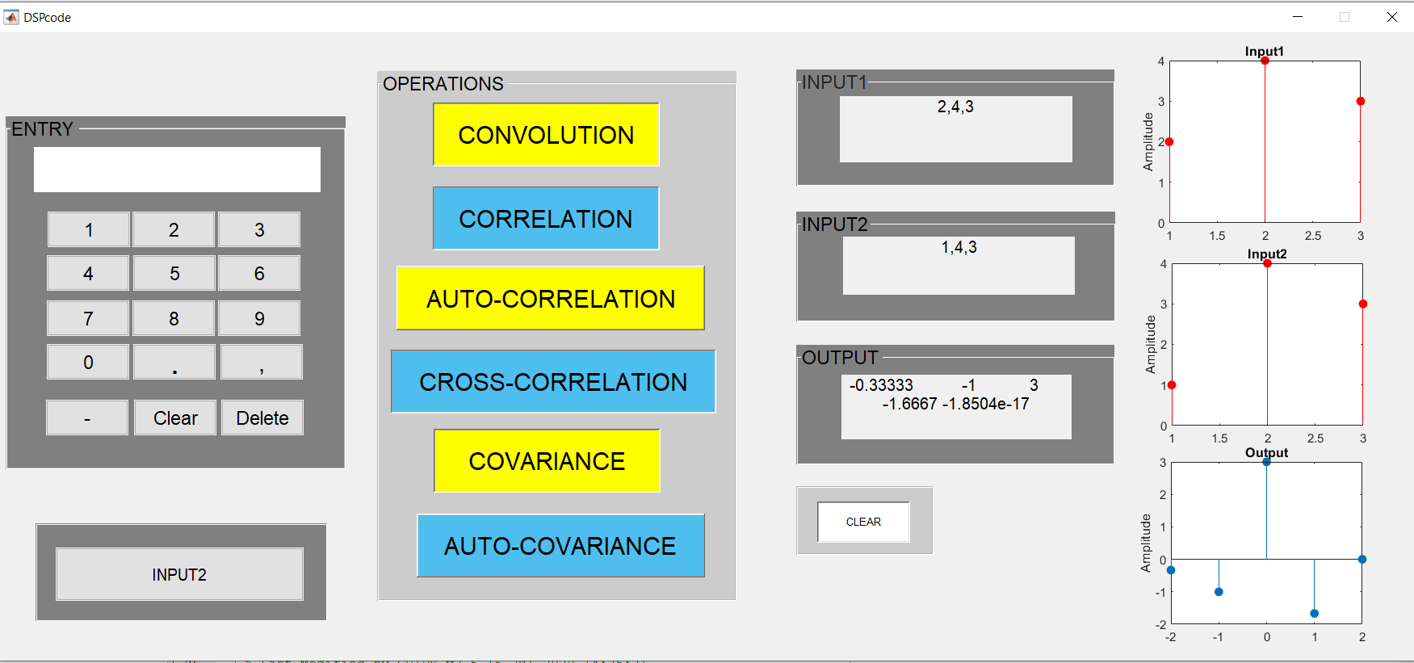

(e)

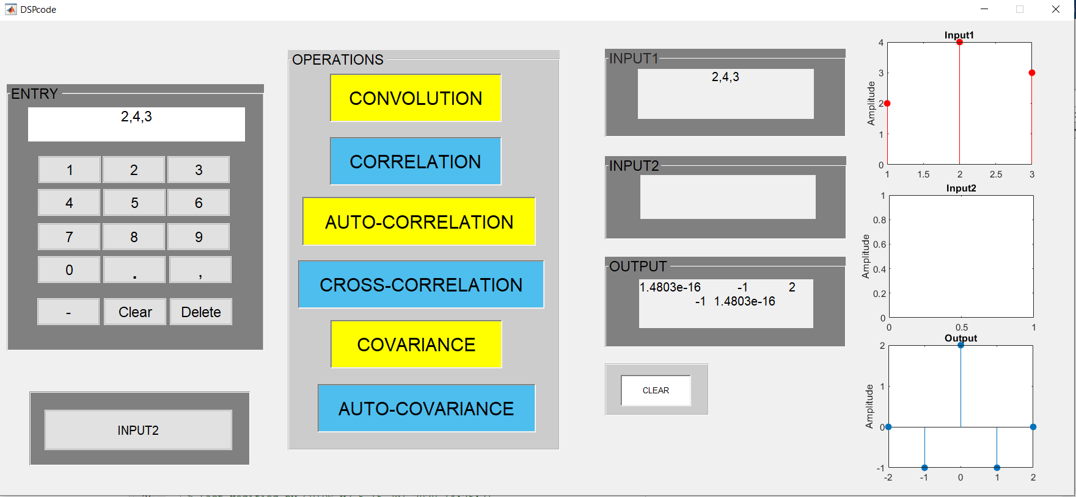

(f)

**Fig.2** – different operation results in GUI platform (a) convolution (b) correlation (c) cross correlation (d) auto correlation (e) covariance (f) auto covariance

For three of the operations, there was been an approach made to find a result without using the in-built function. Those operations are convolution, cross correlation and auto correlation.

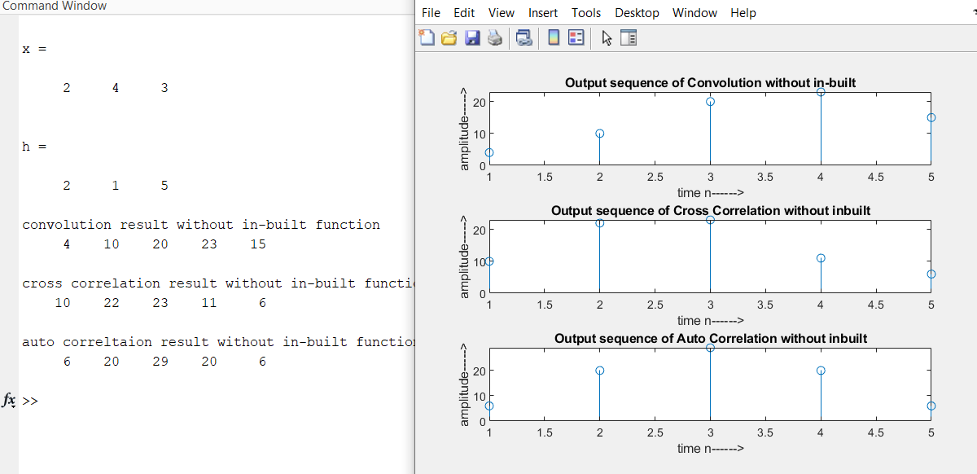

**Fig.3** – operation results without in-built function

In fig.3, the results of three operations that were determined without any in-built function were showed. Fig.1 was done with in-built function. The input for both of the cases was kept same. So the results should be same. If the two figures are compared, they are similar, no difference can be identified in the results. This proves that, the approach without in-built function was made, was accurate.